****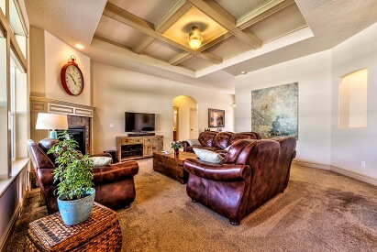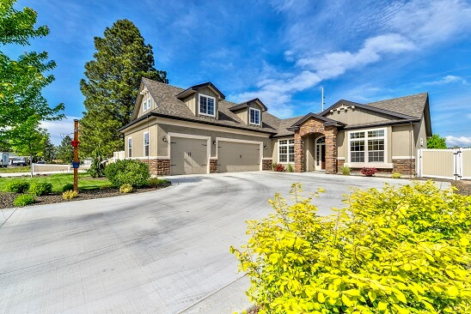



**$300,000**

123 Anywhere Street, City, ID 83###

**Your Name Here**

Designations

**(208) 999-9999**

imarealtor@gmail.com

websitehere.com

This gorgeous home has no backyard neighbors! WOW! This is where you write a MAGICAL review of the home and all the amazing features it has. 5 bedrooms, 4 bathrooms, beautiful master suite with soaker tub, walk-in shower, and a closet the size of a normal bedroom! You want this home? Good. Because you should!

* Bullet
* Point
* List
* Of
* All
* The
* Awesomeness

**EASY WAY TO CHANGE OUT THE PHOTOS:** Right click the photo – “Change Picture” – “From a File...” – pick the photo you want in that space.

**PERFECT LOCATION**

near Schools, Shopping and Parks!